Why did people first need numbers?

Probably the need for numbers is closely tied with people’s sense of tracking items and events in their lives. The number of nights since they last saw the moon in full. The number of livestock that were in pasture yesterday. Number of sunny days required to have a successful harvest. The answers to these questions as well as many others had direct effect on people’s lives. The symbols that are place holders for these answers eventually evolved to become what we currently call numbers and the method of evaluating them is numeration.

What were some of the ways people first kept numerical records?

The easiest method would have been replacement of real object or event with mare accessible substitute. Early human’s fingers were perhaps the most accessible and portable way of substitution. To compensate for the limitations of 10 fingers or 20 fingers and toes tally sticks and knotted strings were used. This led to further refinement and efficiency by grouping. A group could then be represented by a symbol pressed in clay or painted on a surface.

What were the number systems of ancient cultures like?

Once groping and symbolism combined to add efficiency to the system two general systems began to emerge. The literal systems such as the Egyptian and Chines systems used symbols that were noticeable in their daily lives. For instance Egyptians denoted one million with a figure of an astonished man. More abstract systems such as the Roman or Babylonians used more abstract symbols that resembles the alphabet.

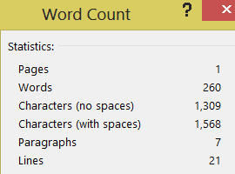

**11/11/2013**